16. Plot of Various Projections of a Sphere
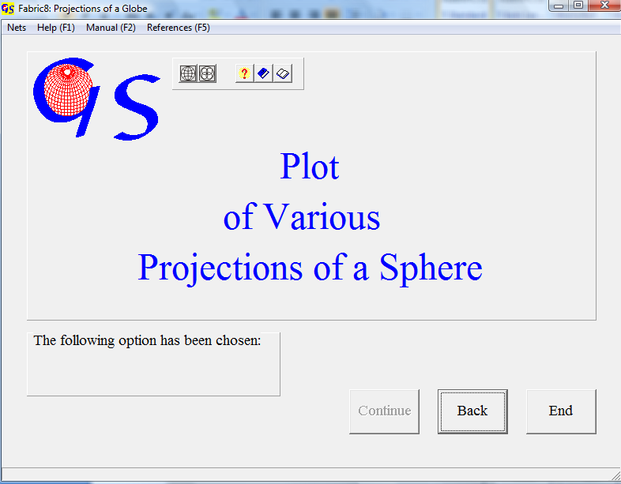
Fig. 1

This program (Fig. 1) plots either nets in various projections or counting grids, also in various projections, which may be used to produce contour line diagrams (Fig. 2).

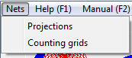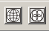
Fig.2

1. Nets in various Projections:

The following projections of a globe can be plotted:

1. a Schmidt net
2. a Wulff net
3. an orthographic net
4. a Kavraiskii net

With the menus "Hemisphere" and “Projection“ the type of projection can be changed.
Fig 3 shows the graphic form for Lambert’s projection (Schmidt net). In the input field on the right side the distance between great and small circle can be chosen. It should be a divisor of 90. The angle of tilt sets the tilt angle of the north-south-axes.

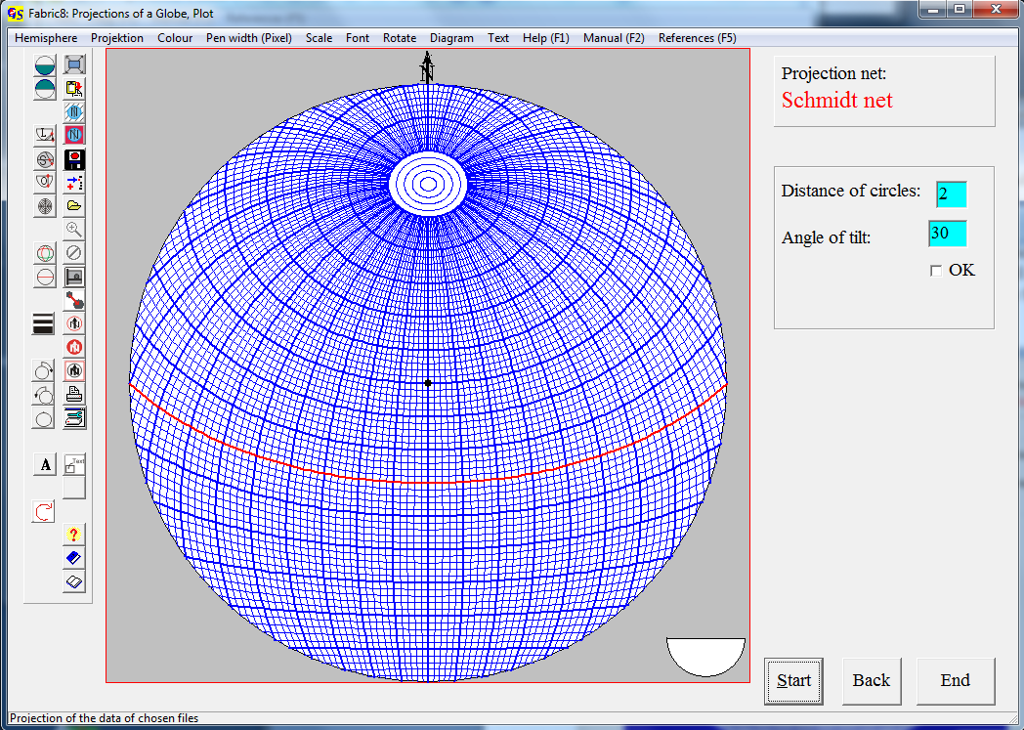
Fig. 3

Fig 4, 5, and 6 show the nets for stereographic (Wulff net), orthographic, and the Kavraiskii projection.
These projections can be used for teaching. Tilted nets can help to carry out rotations about non horizontal axes, or to draw small circles. The orthographic net can also be used to construct block diagrams.
Another application, especially for the Wulff and Schmidt net, is an overlay with the plots of programs 3, 4, 5, 8 to 13. This can be done by saving the net on the clipboard (menu „Graphic“) and pasting it to the graphic form of one of these programs.
A scale can be added to the nets (Fig. 7).

.
Fig. 9 shows a rotated net imported to the program "Contour lines".

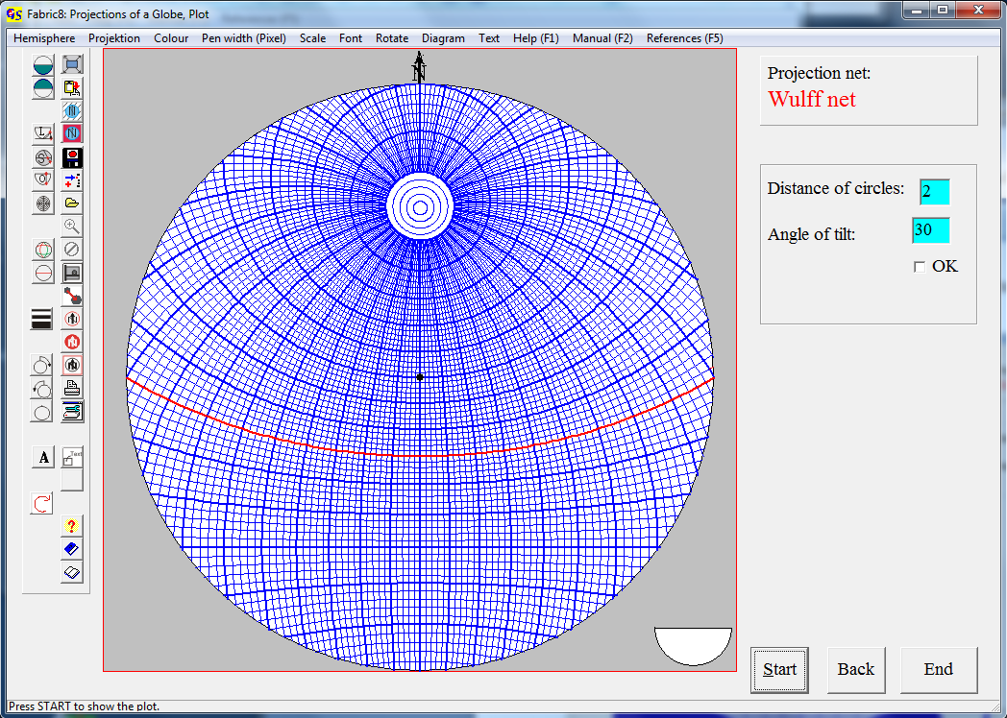
Fig. 4

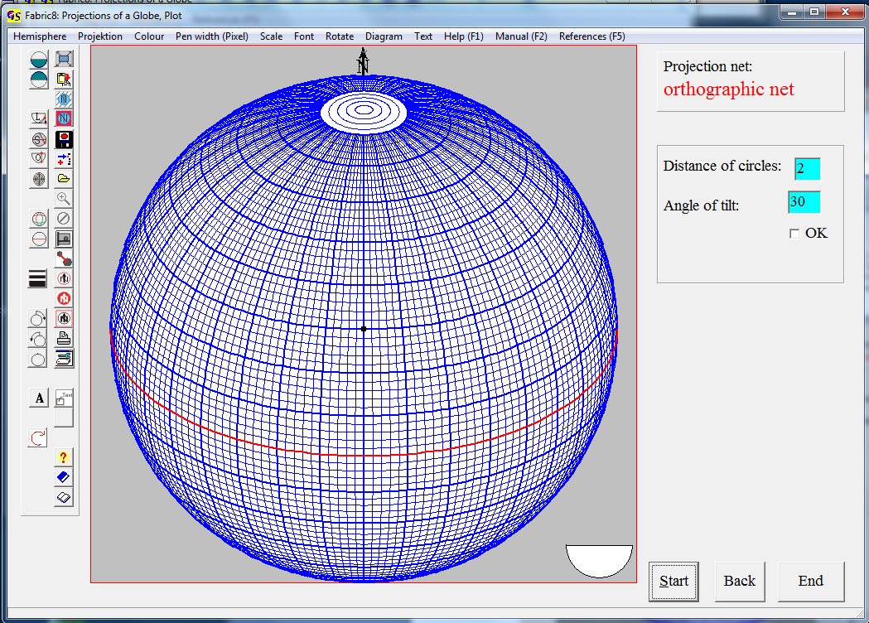
Fig. 5

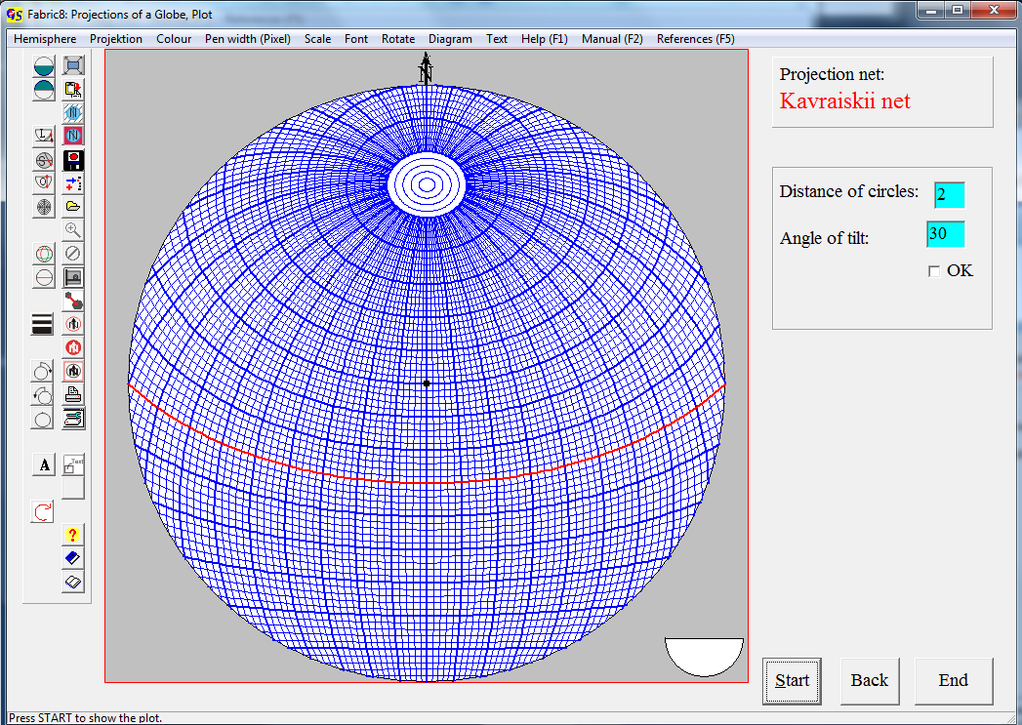

Fig. 6

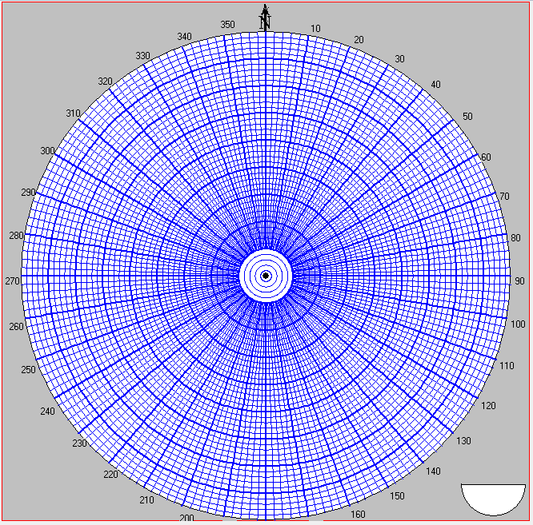
Fig. 7

With the menu "Rotate" the net can be rotated in any direction. Clicking on
"Rotate" opens the input mask 'Azimuth' (Fig. 8).

Enter the direction in which the net shall be rotated and press 'OK'
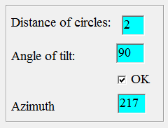
Fig.8

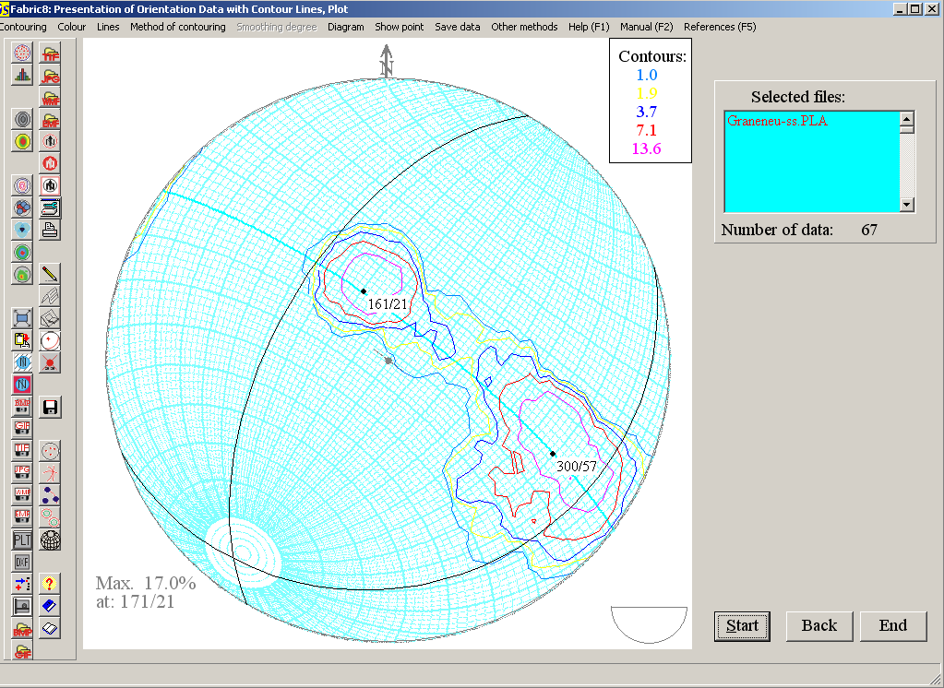
Fig. 9

2. Counting grids:
A square grid is produced. On the intersection points counting calottes are plotted (Fig. 10). Projection method, grid distance, size and colour of the calottes, colour of the diagram, the periphery, the background, and the frame can be selected in the particular menus.
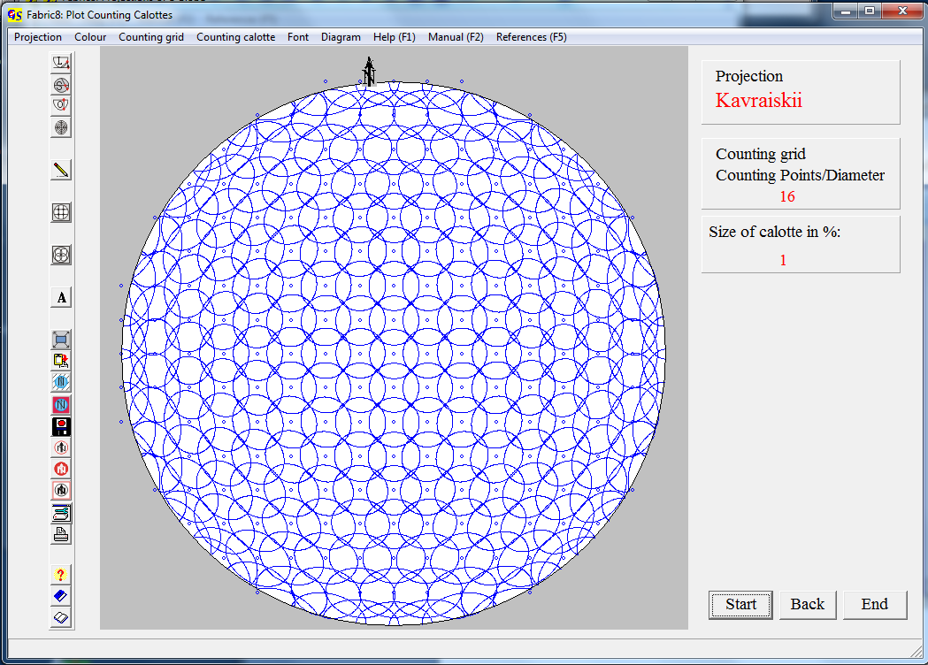Fig. 10.

